Visiting my parents for Christmas



We typically try to stay at least over night when we’re visiting my parents for Christmas, but this year this just wasn’t possible with Theresa’s schedule. So, our trip was more of a mad dash down to see them, and then a dash back towards home in the evening. It felt as if we only had a little bit of time to relax, eat dinner, and exchange gifts before we packed up the car and left.

Fortunately, the drive down was pretty easy thanks to unseasonably warm weather and the lack of snow. After dinner, Josh and I wandered around the yard for a few minutes. He wanted to check the side of his grandfather’s barn for salamanders. I explained to him that there was no way that he would find salamanders in late December, but when I helped him check underneath one of the piles of shingles, we found one. He only made it as far as the kitchen before he was turned away and told that the salamander wasn’t going to be staying in the house. So, he ended up back outside.

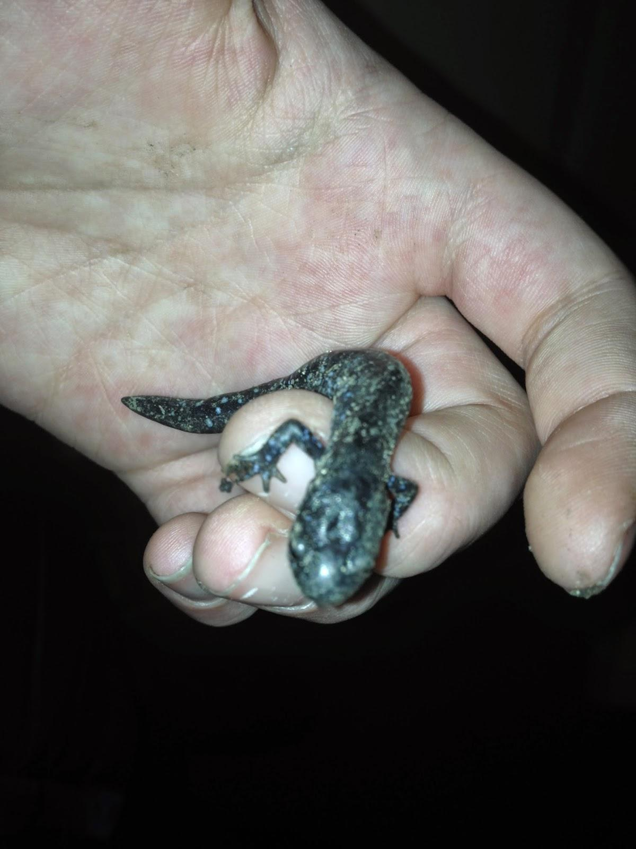

Later, as gifts were being exchanged, Elijah wasn’t as interested in opening up his gifts, but was excited to see what had been inside. My dad opened up his bag of pistachios, and mom opened up the new case I had bought for her iPad mini.

Perhaps the only thing that would have made our stay better was if it was a little longer. We were able to talk before and during dinner, and it was good that the kids saw their grandparents. It was fun watching Elijah run up and down the hallway, and this year he is old enough to climb up Grandma’s staircase while supervised. But, there is something reassuring about just being there.

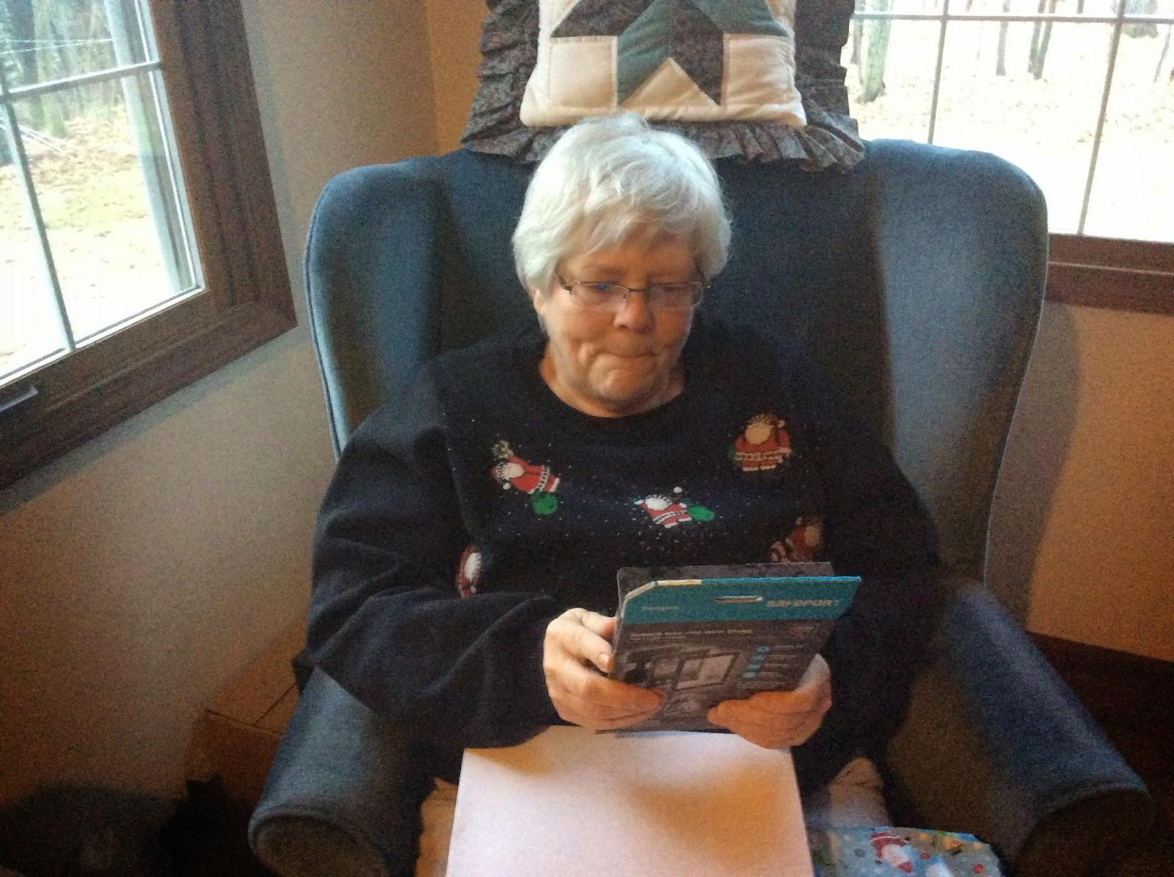







View Online / Respond with Your Story / Send Email